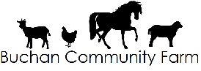
Referral Form

Person Applying | Name:  Contact Details:
Date
Care First number
Person completing form and role | Name:  Position:  Contact Details:
What are the overall outcomes I want to achieve? | Please use the attached How Best to Support Me form to start thinking about this. We will develop these ideas with you if you come to Buchan Community Farm.
What is important to me in this area of my life?
Risk Enablement and Management
Please tell us about any behavioural emotional and physical factors that could impact on your safety and participation:

Guidance on the things to consider can be found on our website:www.buchancommunityfarm.co.uk
Please Return this form to: | Buchan Community Farm  Ashyfolds  Nethermuir  Maud  Peterhead  AB42 5RF | 07790 404655  buchancommunityfarm@gmail.com

